Washington Food Coalition
www.wafoodcoalition.org
PO Box 95752
Seattle, WA 98145
phone: 206.729.0501
fax: 206.729.0504
info@wafoodcoalition.org

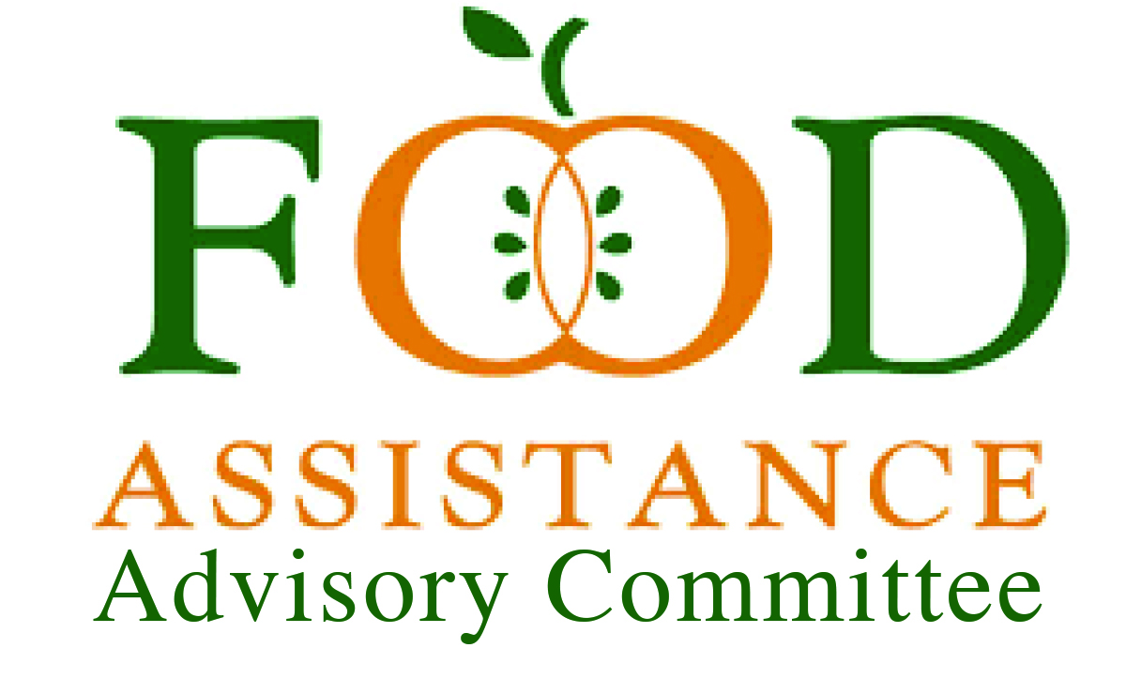

Food Assistance Advisory Committee Mtg
June 9, 2026 2-3:30 PM

AGENDA

Welcome and Review and Approve the April 15 Meeting Minutes (7 min.) |Erik Mora, Chair
- Introductions: Name, organization, and email (chat)
- Please keep camera on for the first 15 minutes

Pulse From Around the State | Petra Vallila-Buchman, Facilitator (15 min.)
- Participants are invited to join a virtual whiteboard space to respond to: What is a key food assistance challenge or opportunity that’s most top-of-mind for you right now?

WFC Reflections: January and April Meetings (25 min.) | Andra Smith, WFC / Erik Mora, Chair
- FAAC purpose and structure
- Input received and next steps

WSDA Updates: Next Biennium (25 min.) | Katie Rains, WSDA

Close & Next Steps (3 min.) | Petra, Facilitator
- Key takeaways and upcoming actions
- Reminder: Next FAAC meeting — Sept TBD

